**NEW River Run Order Entry Site**

When you go to <https://orders.riverruncabinetry.com> here is what the home screen will look like:

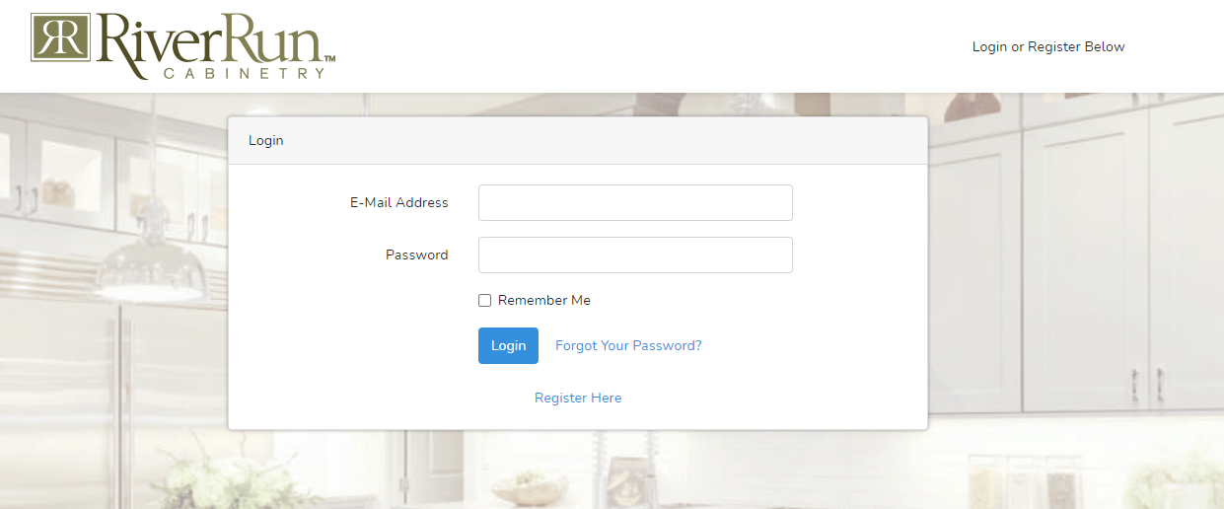

First-time users of the site MUST click the Register Here link at the bottom of the login box to register before logging in.

If you have signed up for the site already you can just log in.

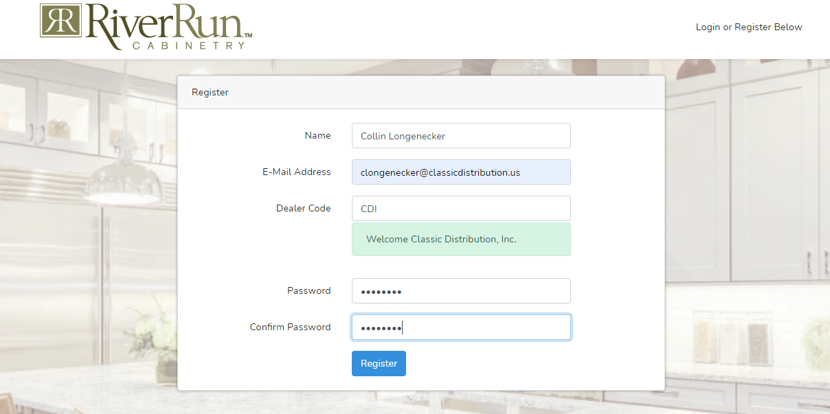

Fill out the information, this is mostly for the user’s benefit other than the DEALER CODE. Must be the code given to the dealer by RiverRun or it will not work. The green bar will come up if a valid code is typed and will show up red if a valid code is not typed.

Once information is complete, click register.

You can then go back to the login screen and type in the information that was just entered.

When logged in the following screen will show up. As a new user, the saved quotes page will be empty.

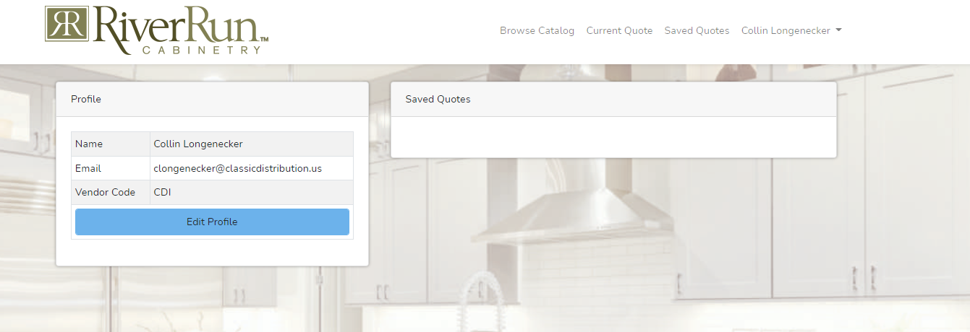

Click the browse catalog header to begin filling out an order:

First, the global options must be selected. Any items added to the quote will receive those global options. It will make you go in order down the list, and you must populate all options before trying to add any products to your quote

There are a few ways to get to the first cabinet you want to add. Either filter your cabinet type with the filter items on the left or simply type a keyword into the filter results. Type “B15” or “rollout” and see the results.

As you find the one you want, click the select over on the right-hand side of the screen.

The following comes up:

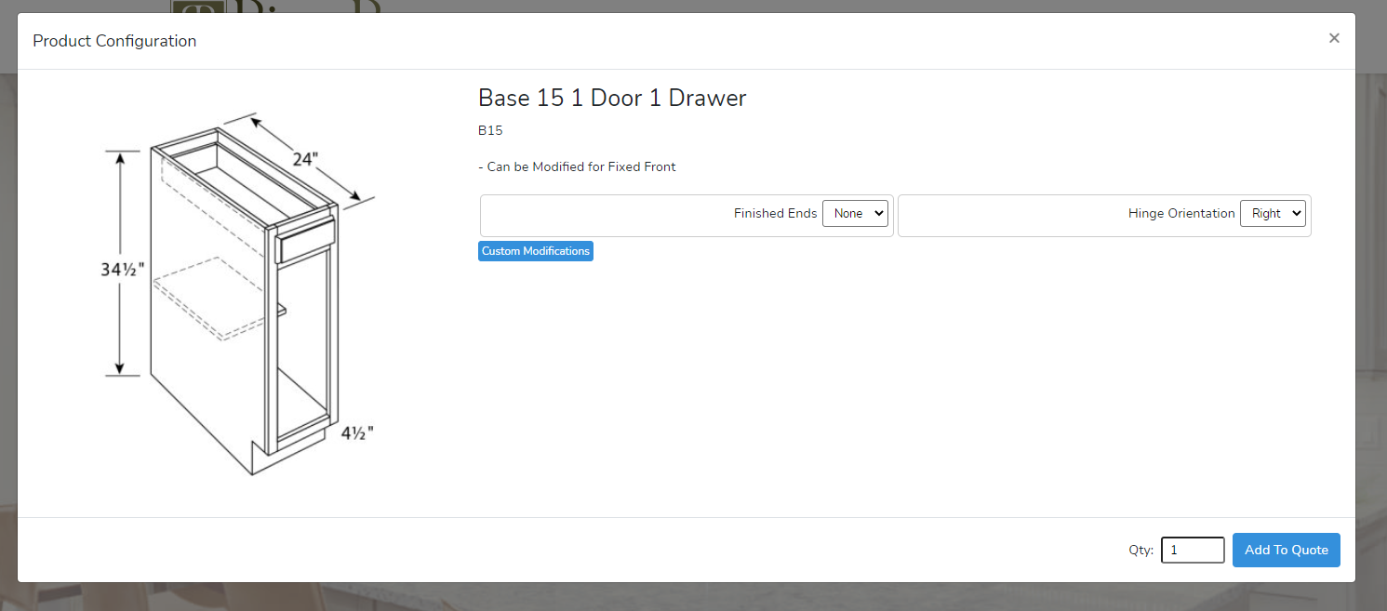

If there is a photo for the product you selected, you will see that on the left-hand side and the description with any notes will be at the top in the middle. The notes can contain important information.

Immediately below that are the options that should always be checked, those are finished ends and the hinge orientation of the cabinet (if cabinet has 1 door).

If you need more modification options, click the custom modifications option below finished ends.

You will then see the list of possible modifications for this specific cabinet. Select the ones you need.

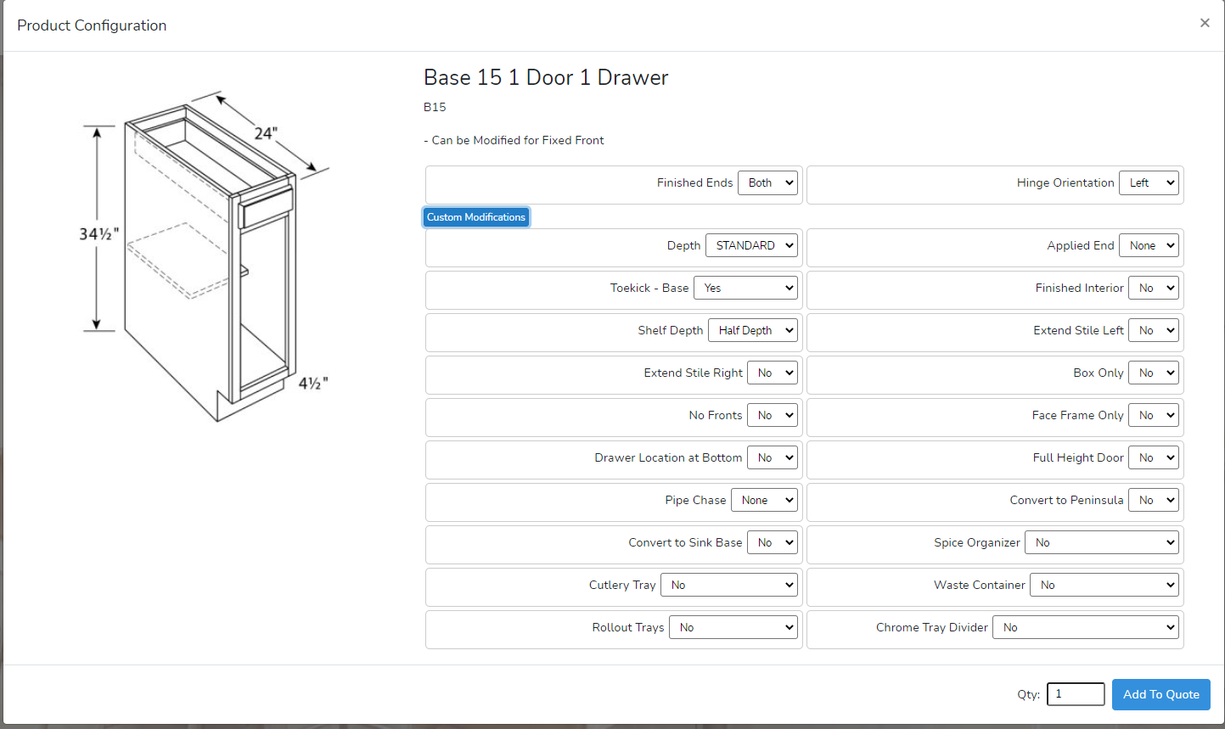

Lastly select the quantity you want for this specific product configuration. And click add to quote.

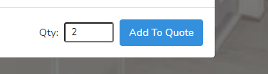

You will then see your product display on the left-hand side of the screen. It will continue to add to the number as items are added to the quote. Continue to add items.

Once you are satisfied with your quote or want to look it over, click on the current quote located at the top of the screen with the number of products in a red circle. There will be a summary of the quote.

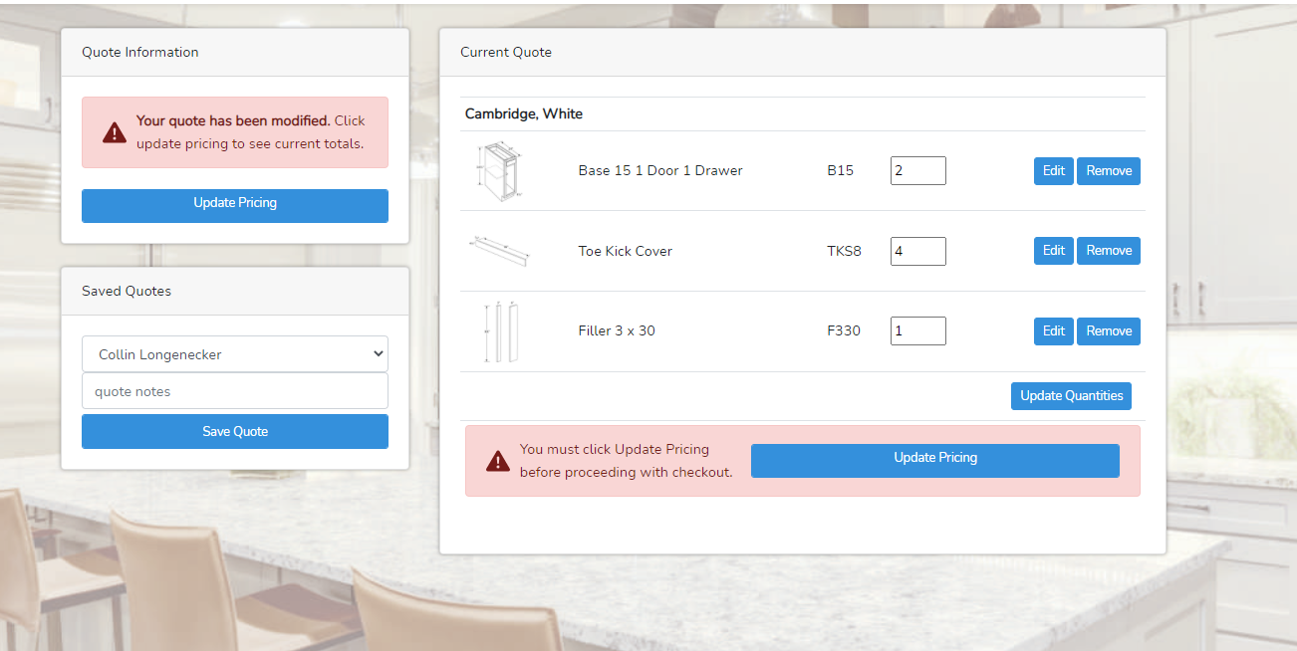

Any time you make changes to a quote this is what the screen will look like. If you want to get pricing for your quote and show the options chosen on each line, just click the update pricing button.

The pricing will come in and your screen should look like this below. The notice at the top will only pop up for orders that are under $1,000 and only really applies to cycle ship orders.

It will now show the configured options for each product along with the price for that configuration. The total pricing for the quote will show up in the quote information box at the top right. If something is not quite right, you can edit or remove what is already there.

You can also go back to the “BROWSE CATALOG” and add more products.

But again, if you add more products or change anything it is always going to make you reprice.

If you do not want to submit this order, you can click the save quote button and put a quote name so you that can keep track of your quotes

Then, if you go to the saved quotes page, you can see your saved quotes there and the note you added. Pricing information is not saved and will need to be recalculated any time you want to see the quote total.

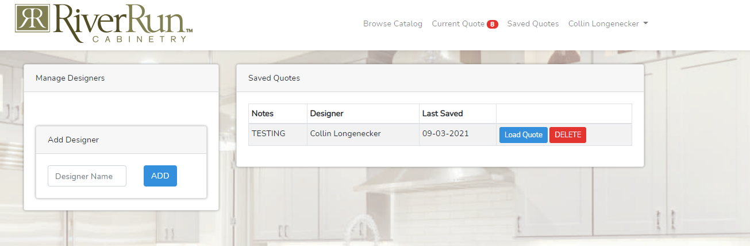

If you want to use a saved quote, just click load quote and if the quote looks good you can update the pricing and proceed to checkout or you can make any changes you need.

If you go back to the current quote, you can get pricing and proceed to checkout. If you would like to go to this step the pricing must be updated.

At any time, you have a few options with your current quote. Print Quote (No Pricing), Print Quote, and Clear Quote. The clear quote is helpful if you have saved quote 1 and you want to start fresh with a new quote. Your old quote will be saved as long as you saved it, so you are not deleting anything when you click this button.

The print quote buttons are helpful if you want to keep the quote for your records OR if you are having any issues with your quote. Sending in this printed quote will greatly accelerate the troubleshooting of your quote.

The Print Quote option that gives you pricing will only show up if you have priced the quote.

Below is what the version with pricing looks like, the version without pricing looks the same but has no price.

As soon as you are ready to submit, click the checkout button at the bottom of the page.

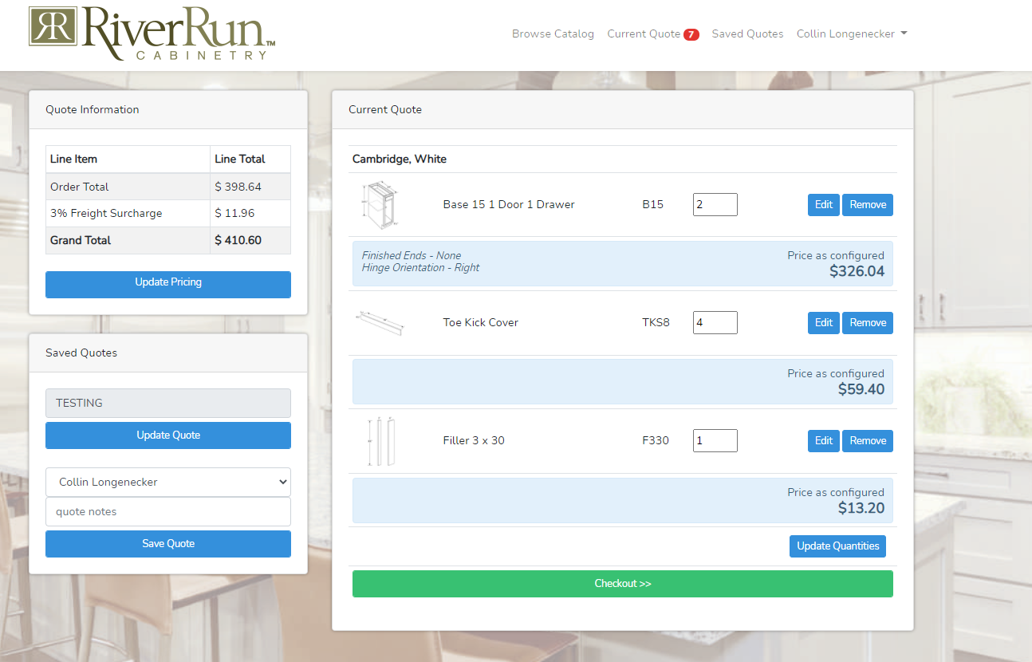

Here will be the overview of the order along with the final submittal information. Once complete, submit the order.

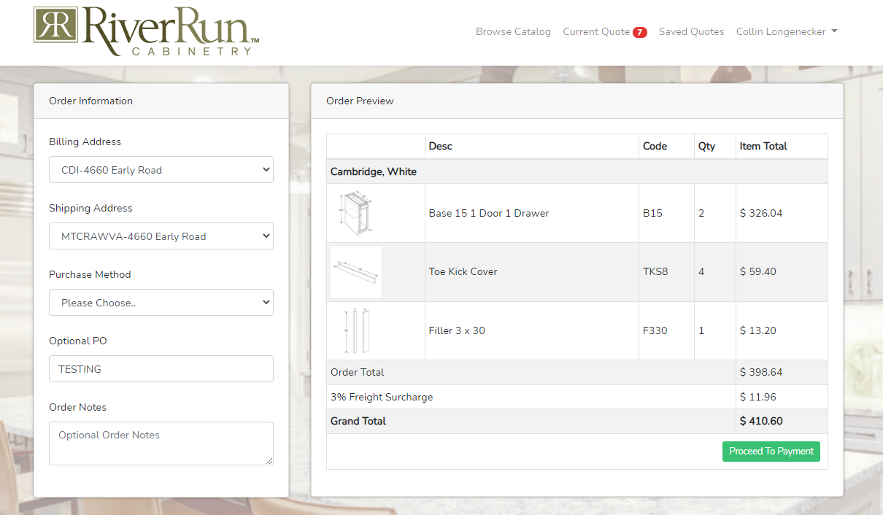

You will receive a web order receipt to your email from the online order site showing you that the order was submitted, and then later on RiverRun will send you an actual Sales Order Acknowledgment that gives greater detail of the order.

You can also use the online order site to track the status of your orders. If you click your name in the top right corner, you will see an order history option.

Once you click that, it will pull live statuses of your orders from our system and because of this, the page might take a second to load all of your data.

You can search POs, Order Dates, Order Numbers, etc. just like the search products works on the browse catalog page.

Here is a key to the statuses that show up:

And here is a description of the columns:

* Order No
  + RiverRun order number
* PO
  + Your PO if you provided one
* Order Date
  + Date your order was submitted and entered into the system
* Est Ship Week
  + Based on current lead time, estimated ship date is provided
* Sched Ship Date
  + Once your order is scheduled for shipment a date will populate here and most of the time it will match the estimated
* Amount
  + Dollar value of the order
* Type
  + CUS means standard order and WARR means warranty
* Ship Method
  + Way you will receive your order
* Status
  + Defined in the key above
* Order Method
  + Shows how your order was placed, whether online, via 2020 Design KIT file, or hand key